

**SOFTWARE REQUIREMENT SPECIFICATION**

**License Marketplace System**

– Hanoi, Jan 2024 –

**Table of Contents**

I. Record of Changes 3

II. Software Requirement Specification 4

1. Overall Requirements 4

1.1 Context Diagram 4

1.2 Main Business Processes 5

1.3 User Requirements 5

1.4 System Functionalities 7

1.5 Entity Relationship Diagram 7

2. Use Case Specifications 8

2.1 <<Feature Name1>> 8

2.2 Xyz Feature 10

3. Functional Requirements 11

3.1 Feature Name1 11

3.2 User Authentication 11

3.3 System Administration 12

4. Non-Functional Requirements 13

3.1 External Interfaces 13

3.2 Quality Attributes 13

5. Requirement Appendix 14

5.1 Business Rules 14

5.2 System Messages 14

5.3 Other Requirements… 15

# I. Record of Changes

|  |  |  |  |
| --- | --- | --- | --- |
| **Date** | **A* M, D** | **In charge** | **Change Description** |
|  |  |  |  |
|  |  |  |  |
|  |  |  |  |
|  |  |  |  |
|  |  |  |  |
|  |  |  |  |
|  |  |  |  |
|  |  |  |  |
|  |  |  |  |
|  |  |  |  |
|  |  |  |  |
|  |  |  |  |
|  |  |  |  |

*A - Added M - Modified D - Deleted

# II. Software Requirement Specification

## 1. Overall Requirements

### 1.1 Context Diagram

**License Marketplace System** is a new web-based platform that streamlines the distribution, sale, and copyright protection of software products, replacing the fragmented and insecure manual processes currently used by independent developers. The context diagram below illustrates the external entities and system interfaces for **Release 1.0**, focusing on secure code submission, automated virus scanning via **3rd Party Security Services**, and real-time license key validation. The system is expected to evolve over several releases, ultimately connecting to recurring billing services for subscription-based software and providing advanced analytics APIs for developers to track user engagement.

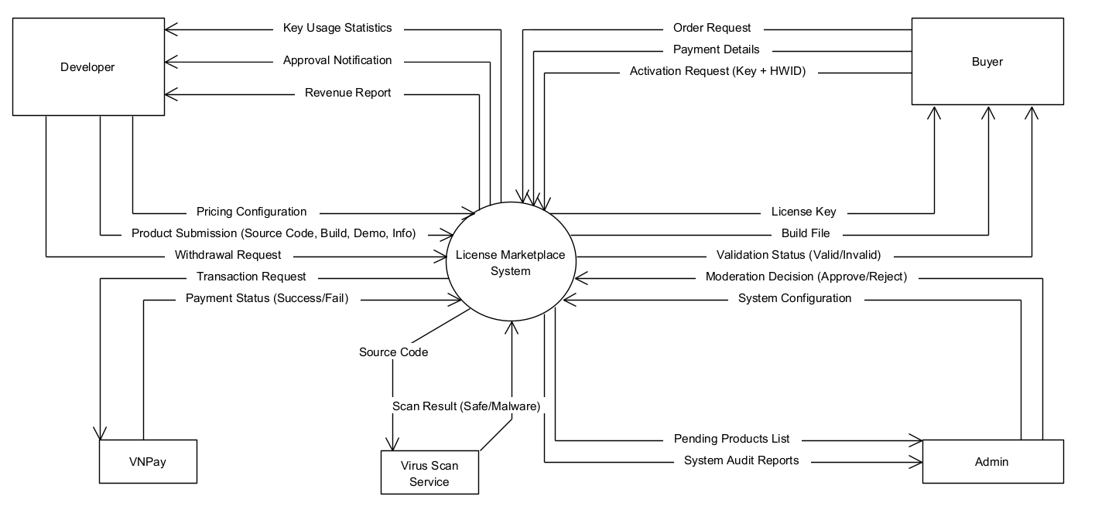

### 1.2 Main Business Processes

#### 1.2.1 Product Submission Processing

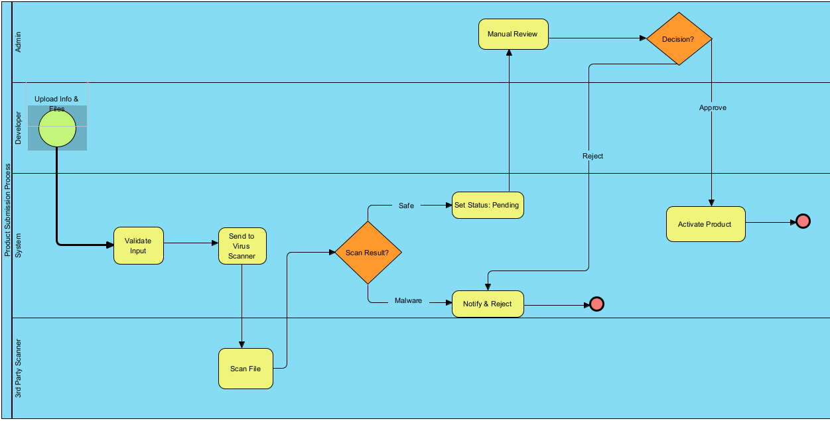

#### 1.2.2 Purchase & License Generation Process

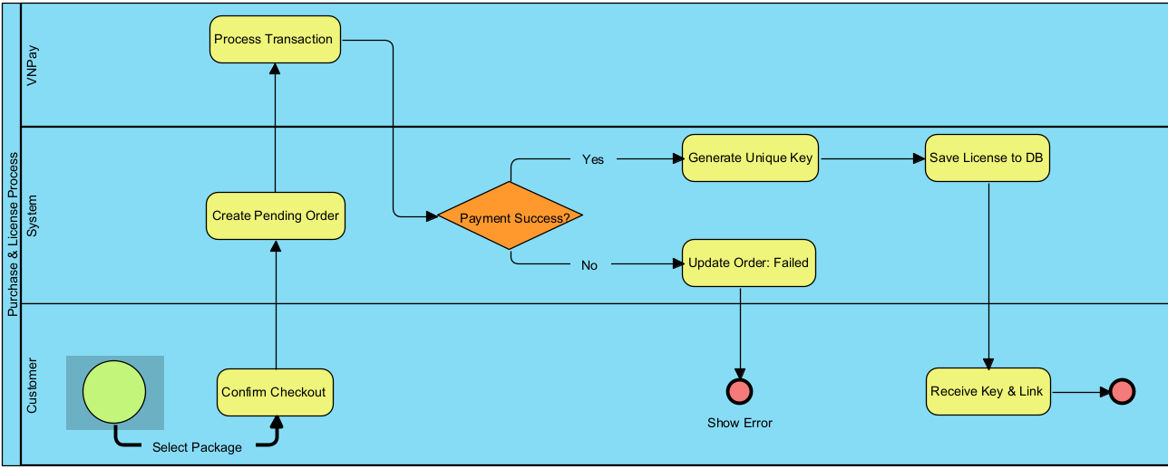

### 1.3 User Requirements

#### 1.3.1 Actors

|  |  |  |
| --- | --- | --- |
| **#** | **Actor** | **Description** |
| 1 | Buyer (End User) | An individual who accesses the system to browse, purchase, and use software licenses. |
| 2 | Developer | An individual or entity who creates software and uses the platform to distribute their products. |
| 3 | Admin | A super-user responsible for managing the platform's operation, content moderation, and system configuration. |
| 4 | Payment Gateway | An external system that processes online financial transactions: VNPay |
| 5 | 3rd Party Security Service | An external system used for automated malware and virus scanning: |
| 6 | Client Software | The software installed on the Buyer's machine that interacts with the system for license validation. |

#### 1.3.2 Use Cases (UC)

|  |  |  |  |
| --- | --- | --- | --- |
| **UC ID** | **Use Case Name** | **Primary Actor** | **Description (Outcome of Value)** |
| **UC-01** | Register Account | Buyer, Developer | The actor creates a new account on the system to access restricted features (buying or selling). |
| **UC-02** | Log In | All Actors | The actor authenticates their identity to access their specific dashboard and permissions. |
| **UC-03** | Search Products | Buyer (Guest) | The actor searches for software by name, category, or filter to find a product of interest. |
| **UC-04** | View Product Details | Buyer (Guest) | The actor views detailed information (video, description, pricing) of a specific product to make a purchase decision. |
| **UC-05** | Purchase License | Buyer | The actor selects a license package (e.g., monthly, lifetime) and completes the payment process to obtain the right to use the software. |
| **UC-06** | Download Product | Buyer | The actor retrieves the installation file (build) of the purchased software from the system. |
| **UC-07** | Submit New Product | Developer | The actor uploads product details, source code, and build files for administrator review. |
| **UC-08** | Manage Pricing Packages | Developer | The actor defines or updates the cost and duration (e.g., 1 month, 1 year) for their software licenses. |
| **UC-09** | Request Withdrawal | Developer | The actor requests a payout of their accumulated earnings from the system wallet to their bank account. |
| **UC-10** | Approve Product | Administrator | The actor reviews a submitted product (and its virus scan results) and publishes it to the marketplace. |
| **UC-11** | Reject Product | Administrator | The actor declines a submitted product due to policy violations or malware detection, providing a reason to the Developer. |
| **UC-12** | Process Withdrawal | Administrator | The actor reviews a financial withdrawal request and transfers funds to the Developer. |
| **UC-13** | Ban User | Administrator | The actor locks a specific user account to prevent access due to suspicious activity or policy violations. |
| **UC-14** | Activate License | Client App (User) | The Client Application (acting on behalf of the user) validates the input key and hardware ID with the server to unlock the software. |

#### 1.3.2 Use Case Diagrams

##### 1.3.2.1 UCs for Buyer

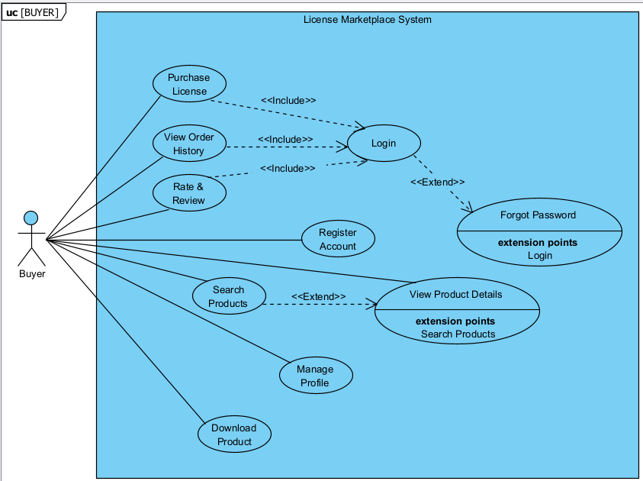

##### 1.3.2.2 UCs for Developer

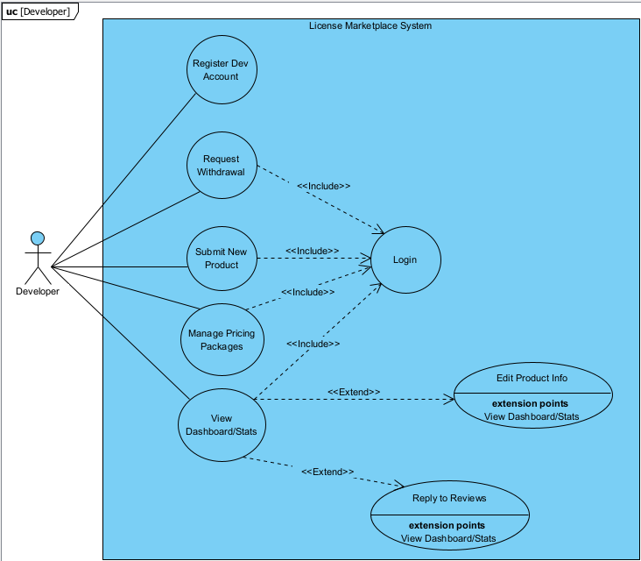

##### 1.3.2.3 UCs for Admin

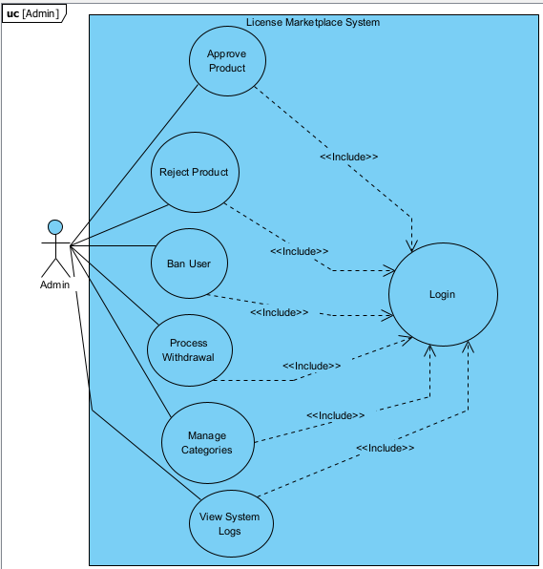

### 1.4 System Functionalities

#### 1.4.1 Screens Flow

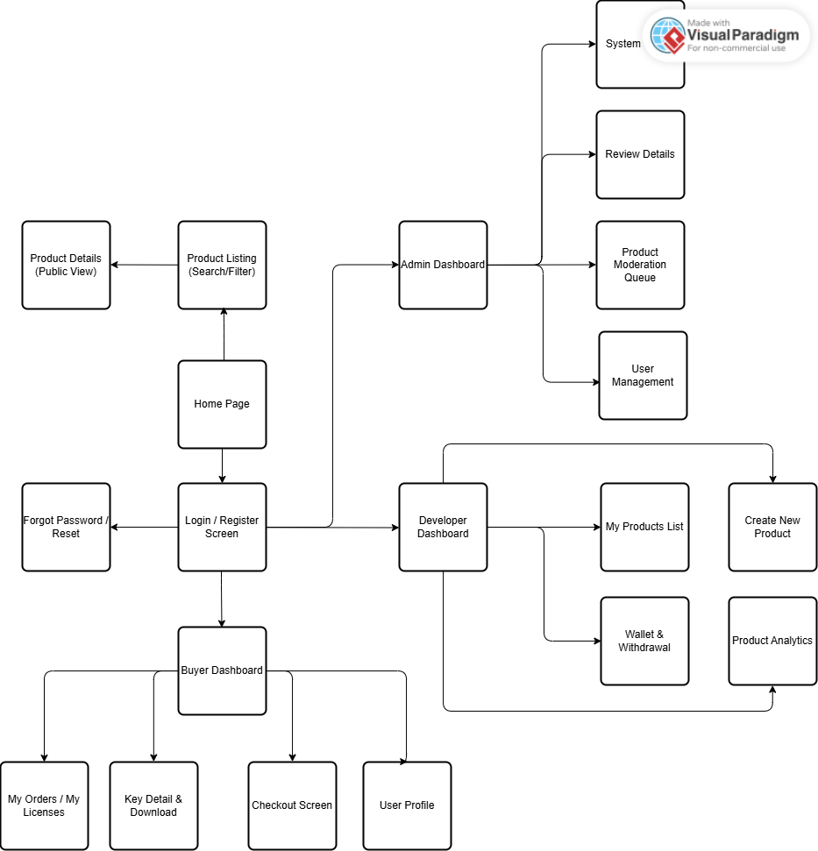

#### 1.4.2 Screen Authorization

|  |  |  |  |  |
| --- | --- | --- | --- | --- |
| **Screen / Feature** | **Guest** | **Buyer** | **Developer** | **Administrator** |
| **Public Screens** | | | | |
| Home Page | X | X | X | X |
| Login / Register | X |  |  |  |
| Product Listing (Search/Filter) | X | X | X | X |
| Product Details (Public View) | X | X | X | X |
| Forgot Password | X |  |  |  |
| **Buyer Screens** | | | | |
| Buyer Dashboard |  | X |  |  |
| My Licenses / My Orders |  | X |  |  |
| Key Detail & Download |  | X |  |  |
| Checkout / Payment |  | X |  |  |
| User Profile (Buyer View) |  | X |  |  |
| **Developer Screens** |  |  |  |  |
| Developer Dashboard |  |  | X |  |
| Create New Product |  |  | X |  |
| Manage Products List |  |  | X |  |
| Wallet & Withdrawal |  |  | X |  |
| Product Analytics |  |  | X |  |
| **Admin Screens** | | | | |
| Admin Dashboard |  |  |  | X |
| Product Moderation Queue |  |  |  | X |
| Review Product Details |  |  |  | X |
| User Management (Ban/Unban) |  |  |  | X |
| System Configuration |  |  |  | X |
| Transaction History (All) |  |  |  | X |

#### 1.4.3 Non-UI Functions

*[Provide the descriptions for the non-screen system functions, i.e batch/cron job, service, API, etc.]*

|  |  |  |  |
| --- | --- | --- | --- |
| **#** | **Feature** | **System Function** | **Description** |
| 1 | <<Feature Name>> | <<Function Name1>> | <<Function Name1 Description>> |
| 2 | … |  |  |

### 1.5 Entity Relationship Diagram

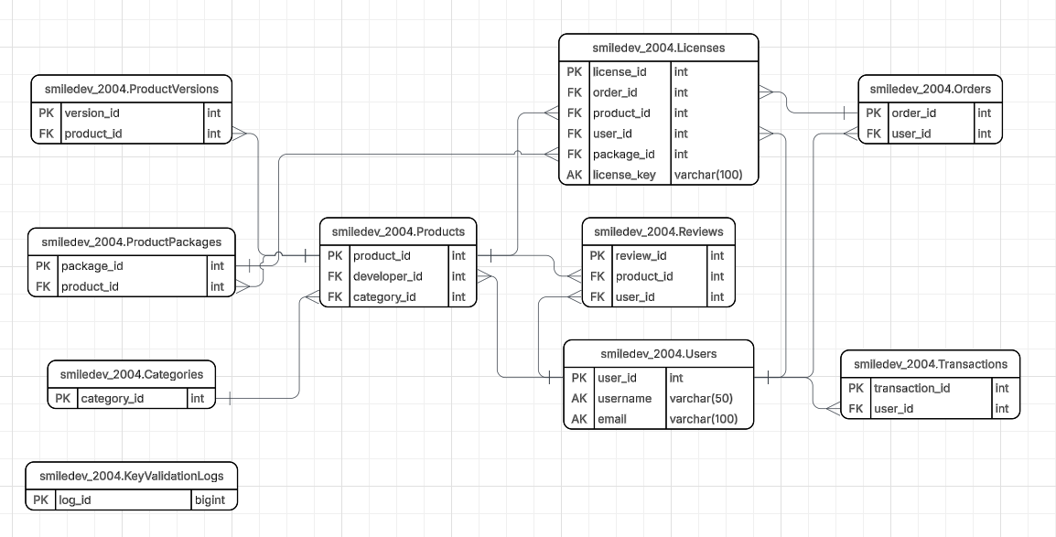

**Entities Description**

|  |  |  |
| --- | --- | --- |
| **#** | **Entity** | **Description** |
| 1 | Users | Stores account information for all system roles (Admin, Developer, Buyer). It manages authentication credentials, profile details, and the digital wallet balance. |
| 2 | Products | Contains core information about the software listed by Developers (e.g., name, description, demo video). It serves as the central entity linking Developers to Buyers. |
| 3 | ProductVersions | Manages the versioning history of software (e.g., v1.0, v1.1). It stores file paths for both Source Code (for Admin security checks) and Build Files (for User downloads). |
| 4 | ProductPackages | Defines the pricing models and duration limits for each product (e.g., "1-Month Subscription", "Lifetime License"). |
| 5 | Categories | Manages software classifications (e.g., System Tools, Game Assets, UI Kits) to help users categorize and filter products effectively. |
| 6 | Orders | Records purchase transactions made by Buyers. It tracks the total amount, payment method, and the current payment status (Pending/Completed). |
| 7 | Licenses | (Core Entity) Stores the unique license keys generated upon successful orders. It manages critical DRM data including expiration dates, activation status, and the bound Hardware ID. |
| 8 | Transactions | Logs the history of all financial movements within the system, including deposits, purchase deductions, developer revenue credits, and withdrawals. |
| 9 | Reviews | Stores feedback and ratings (1-5 stars) provided by Buyers for purchased products, helping to establish product quality and trust. |
| 10 | ActivityLogs | An audit trail that records critical actions performed by Administrators and Developers (e.g., Approving a product, Changing configuration) for security and accountability. |
| 11 | KeyValidationLogs | Logs the history of API requests from client software when validating licenses. Used for monitoring usage frequency and detecting potential piracy attempts. |

## 2. Use Case Specifications

### 2.1 Feature: Product Management

#### 2.1.2 UC-07: Submit New Product

| Primary Actors | Developer |
| --- | --- |
| Secondary Actors | 3rd Party Security Service (Virus Scanner) |
| Description | As a Developer, I want to upload my software (source code, build files, and details) so that it can be reviewed by the Admin and listed for sale on the marketplace. |
| Preconditions | 1. The Developer must be logged in to the system.2. The Developer account must be active (not banned). |
| Postconditions | 1. A new product record is created in the database with status "Pending".2. Source code and build files are stored securely on the server.3. An asynchronous request is sent to the 3rd Party Security Service to scan the uploaded files. |
| Normal Sequence/Flow | User Actions:Developer accesses the "Create New Product" screenDeveloper enters product metadata (Name, Description, Category)Developer uploads the required files: Source Code (.zip) and Build File (.exe/.msi).Developer configures the pricing packages (e.g., Monthly, Lifetime).Developer clicks the "Submit" button.System Responses:System validates the input data (file size, file format, required fields).System uploads files to the storage server.System records the product information in the database.System triggers an API call to the 3rd Party Security Service to initiate a malware scanSystem displays a success message: "Product submitted successfully and is pending review." |
| Alternative Sequences/Flows | A1. Invalid File Format:At step 6, if the uploaded file is not in the allowed format (e.g., .bat, .sh), the System displays an error message "Invalid file format" and terminates the flow. The Developer remains on the screen to correct the file.A2. Missing Pricing Config:At step 6, if no price package is defined, the System prompts the Developer to add at least one pricing option. |

### 2.2 Feature: Purchase & Licensing

#### 2.1.2 UC-07: Submit New Product

|  |  |
| --- | --- |
| **Primary Actors** | **Buyer** |
| **Secondary Actors** | Payment Gateway (e.g., VNPay/PayPal) |
| **Description** | As a Buyer, I want to purchase a license package for a specific software so that I can download and use it legally. |
| **Preconditions** | 1. The Buyer is logged in.  2. The selected Product is in "Approved" status.  3. The Product has valid pricing packages configured. |
| **Postconditions** | 1. A new Order is created with status "Completed".  2. A unique License Key is generated and assigned to the Buyer.  3. The Developer's wallet balance is credited (revenue).  4. The Buyer receives the download link. |
| **Normal Sequence/Flow** | User Actions:  1. Buyer views the Product Detail page and clicks "Buy Now" on a specific package.  2. System displays the Order Summary (Price, Tax, Total).  3. Buyer confirms and selects a payment method.  4. System redirects Buyer to the Payment Gateway interface.  5. Buyer enters payment credentials and confirms transaction.System Responses:  6. Payment Gateway processes the transaction and returns a "Success" signal to the System.  7. System updates the Order status to "Completed".  8. System calls the License Key Generator service to create a unique key.9. System saves the License Key to the database (linked to the Order).  10. System redirects Buyer to the "My Licenses" screen displaying the new Key and Download button. |
| **Alternative Sequences/Flows** | A1. Payment Failed:At step 6, if the Payment Gateway returns "Failed" or "Insufficient Funds":- System updates Order status to "Failed".- System displays an error message "Payment failed, please try again."- System redirects Buyer back to the Checkout screen.  A2. Transaction Timeout:If the user takes too long at step 5, the session expires. The System cancels the pending order and redirects the user to the Home page. |

### 2. 3 Feature: DRM System (Digital Rights Management)

#### 2. 3.1 UC-14: Activate License (Check Key)

|  |  |
| --- | --- |
| **Primary Actors** | **Client Application (Acting on behalf of User)** |
| **Secondary Actors** | None |
| **Description** | When the user opens the software, the Client App communicates with the System API to validate the license key and bind it to the hardware, ensuring the key is valid and not pirated. |
| **Preconditions** | 1. The User has installed the software.  2. The User has a valid License Key.  3. The User's device has an internet connection. |
| **Postconditions** | 1. If valid: The software unlocks features. The Hardware ID is bound to the Key in the database (if first time).  2. If invalid: The software denies access. |
| **Normal Sequence/Flow** | User/App Actions:  1. User launches the software and enters the License Key.  2. Client App retrieves the device's Hardware ID (HWID).  3. Client App sends an API request (Key + HWID) to the System.System Responses:  4. System checks if the Key exists in the database.  5. System checks if the Key is expired (Current Date > Expiration Date).  6. System checks the HWID binding:    a. If HWID in DB is NULL: System updates the DB with the current HWID.    b. If HWID in DB matches current HWID: Proceed.  7. System returns a "Success/Valid" token to the Client App.  8. Client App unlocks the interface for the user. |
| **Alternative Sequences/Flows** | A1. Key Not Found / Expired:At step 4 or 5, if the check fails, System returns "Invalid/Expired" status. Client App displays "License is invalid or expired" and locks the software.  A2. Hardware Mismatch (Piracy Detected):At step 6, if the HWID in DB is different from the current HWID (meaning key is already used on another device), System returns "Hardware Mismatch". Client App displays "This key is already used on another device." |

## 3. Functional Requirements

*[Provide descriptions about the system’s functions/screens. The functions/screens are grouped by the system features, and even sub-features if needed. For the screens, you need to provide the screen layouts (mock-up screens) and relevant specifications if needed]*

### 3.1 Feature Name1

#### 3.1.1 SubFeature Name1.1

##### 3.1.1.1 Screen/Function Name1

*[Content #1: UI layout (Mockup screen prototype)]*

*[Content #2: brief descriptions of the screen/function, mapped to the relevant use cases]*

*[Content #3: provide further descriptions for the screen’s components/fields using table format below]*

|  |  |
| --- | --- |
| **Field Name** | **Description** |
| Field Name1 | Field description: data type min/max length or value, initial data, etc. |
| Field Name2 | … |
| ***Field Group-Name1*** | |
| Field Name3 | … |
| Field Name4 | … |
| ***Field Group-Name2*** | |
| … | … |

##### 3.1.1.2 Screen/Function Name2

…

#### 3.1.2 SubFeature Name1.2

…

### 3.2 User Authentication

#### 3.2.1 User Register

…

#### 3.2.2 User Login

…

#### 3.2.3 Password Reset

…

### 3.3 System Administration

#### 3.3.1 Master Data

##### 3.3.1.1 Setting List

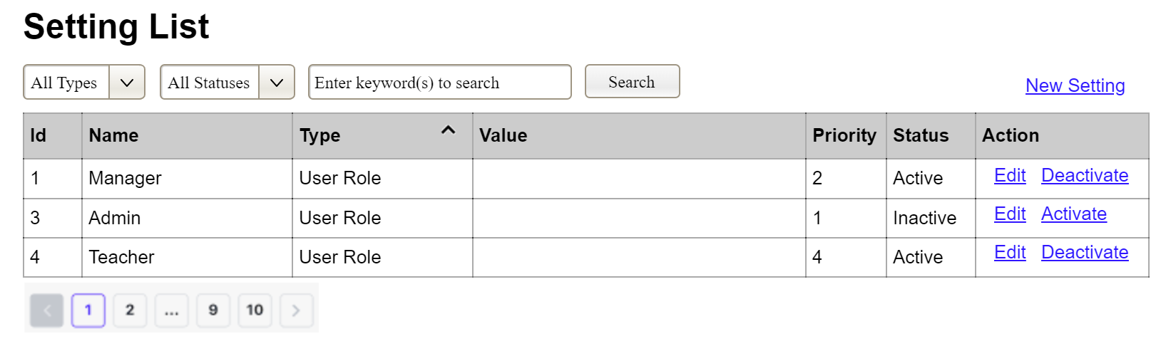

(1)

(2)

(3)

This screen allows the Administrator to:

* View Setting List: view list of current master data.
* Filter Setting List: filter master data by data types, statuses
* Search Settings: enter keyword(s) to search master data by their names or values
* Sort Setting List: sort master data list (ascending, descending) by clicking column headers

On the screen, s/he can also

* Activate/Deactivate Setting: change status of a specific inactive/active master data
* Choose to go to the Setting Details screens for adding new or updating an existing master data by clicking the New Setting or Edit link.

**Field Description**

|  |  |
| --- | --- |
| **Field Name** | **Description** |
| (1) | Initial values: all the active setting names with null or blank type  Hover the mouse to show the field name: “Setting Type” |
| (2) | Initial values: All Statuses, Active, Inactive (default value “All Status”)  Hover the mouse to show the field name: “Setting Status” |
| (3) | The change-status action is Activate or Deactivate depending on the current status of the relevant setting (Inactive or Active, respectively). |

##### 3.3.1.2 Setting Details

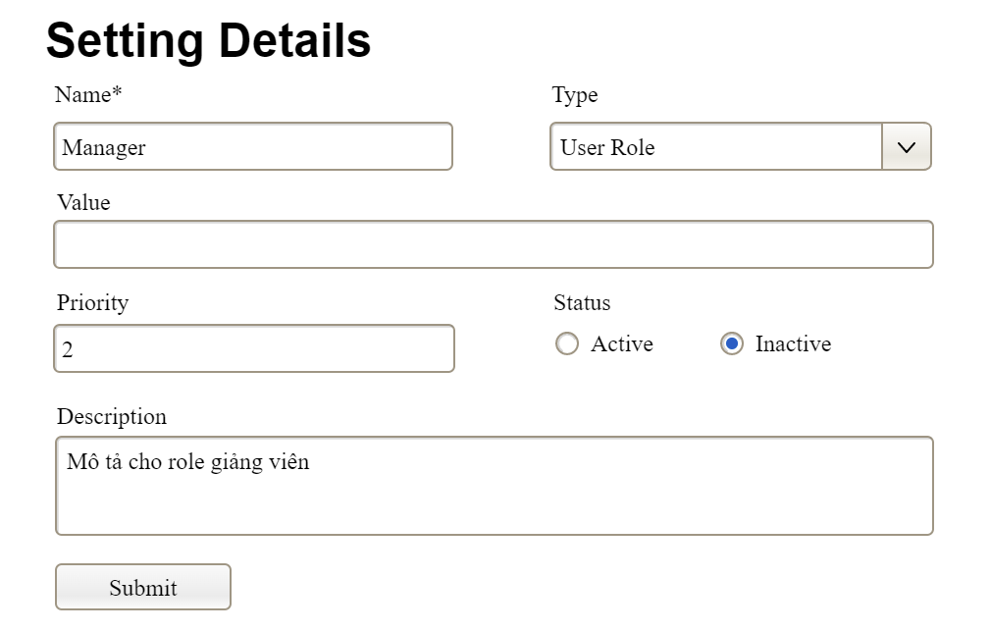

This screen allows the Administrator to:

* Add New Setting: add new master data.
* Update Setting Details: update details of a specific master data

**Field Description**

|  |  |
| --- | --- |
| **Field Name** | **Description** |
| Name | Data type: non-digit string, max length of 20 characters |
| Type | Initial data values: all active setting names (with null or blank type) |
| Value | Data type: any string, max length of 100 characters |
| Priority | Data type: a positive integer |
| Description | Data type: any string, max length of 200 characters |

#### 3.3.2 User Management

##### 3.3.2.1 User List

…

##### 3.3.2.2 User Details

…

## 4. Non-Functional Requirements

### 3.1 External Interfaces

*[This section provides information to ensure that the system will communicate properly with users and with external hardware or software/system elements.]*

### 3.2 Quality Attributes

*[List all the required system characteristics (quality attributes) specification. Some of the possible attributes are provided with the guide/descriptions are mentioned here]*

#### 3.2.1 Usability

*[This section includes all those requirements that affect usability. For example, specify the required training time for a normal user and a power user to become productive at particular operations specify measurable task times for typical tasks or base the new system’s usability requirements on other systems that the users know and like specify requirement to conform to common usability standards, such as IBM’s CUA standards Microsoft’s GUI standards]*

#### 3.2.2 Performance

*[The system’s performance characteristics are outlined in this section. Include specific response times. Where applicable, reference related Use Cases by name.*

*Response time for a transaction (average, maximum)*

*Throughput, for example, transactions per second*

*Capacity, for example, the number of customers or transactions the system can accommodate*

*Resource utilization, such as memory, disk, communications, and so forth.]*

#### 3.2.3 …

## 5. Requirement Appendix

*[Provide business rules, common requirements, or other extra requirements information here]*

### 5.1 Business Rules

*[Provide common business rules that you must follow. The information can be provided in the table format as the sample below]*

|  |  |
| --- | --- |
| **ID** | **Rule Definition** |
| BR-01 | Delivery time windows are 15 minutes, beginning on each quarter hour. |
| BR-02 | Deliveries must be completed between 10:00 A.M. and 2:00 P.M. local time, inclusive. |
| BR-03 | All meals in a single order must be delivered to the same location. |
| BR-04 | All meals in a single order must be paid for by using the same payment method. |
| BR-11 | If an order is to be delivered, the patron must pay by payroll deduction. |
| BR-12 | Order price is calculated as the sum of each food item price times the quantity of that food item ordered, plus applicable sales tax, plus a delivery charge if a meal is delivered outside the free delivery zone. |
| BR-24 | Only cafeteria employees who are designated as Menu Managers by the Cafeteria Manager can create, modify, or delete cafeteria menus. |
| BR-33 | Network transmissions that involve financial information or personally identifiable information require 256-bit encryption. |
| BR-86 | Only regular employees can register for payroll deduction for any company purchase. |
| BR-88 | An employee can register for payroll deduction payment of cafeteria meals if no more than 40 percent of his gross pay is currently being deducted for other reasons. |

### 5.2 System Messages

|  |  |  |  |  |
| --- | --- | --- | --- | --- |
| **#** | **Message code** | **Message Type** | **Context** | **Content** |
| 1 | MSG01 | In line | There is not any search result | *No search results.* |
| 2 | MSG02 | In red, under the text box | Input-required fields are empty | *The * field is required.* |
| 3 | MSG03 | Toast message | Updating asset(s) information successfully | *Update asset(s) successfully.* |
| 4 | MSG04 | Toast message | Adding new asset successfully | *Add asset successfully.* |
| 5 | MSG05 | Toast message | Confirming email of asset hand-over is sent successfully | *A confirmation email has been sent to {email_address}.* |
| 6 | MSG06 | Toast message | Resetting asset information successfully | *Return asset(s) successfully.* |
| 7 | MSG07 | Toast message | Deleting asset information successfully | *Delete asset(s) successfully.* |
| 8 | MSG08 | In red, under the text box | Input value length > max length | *Exceed max length of {max_length}.* |
| 9 | MSG09 | In line | Username or password is not correct when clicking sign-in | *Incorrrect user name or password. Please check again.* |
| 10 | .. |  |  |  |

### 5.3 Other Requirements…